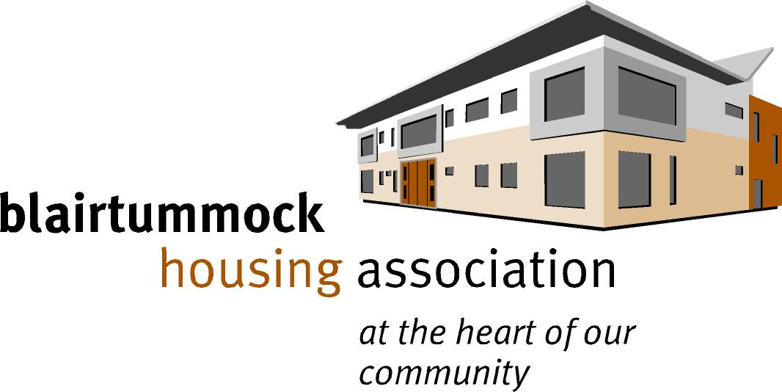

**HOUSING ASSISTANT VACANCY**

**APPLICATION PACK**

**Index**

**1. Background Information on Blairtummock HA**

**2. Organisational Structure**

**3. Summary Terms & Conditions**

**4. Job Description**

**5. Person Specification**

**BLAIRTUMMOCK HOUSING ASSOCIATION**

**BACKGROUND INFORMATION**

Blairtummock Housing Association was registered as a Housing Association in May 1990 and has had two stock transfers from Glasgow City Council and two from Glasgow Housing Association. Since January 1992 the Association has refurbished some of these properties and demolished others which have been replaced with new build.

At present, the Association has:

- 701 homes in rent

- 18 homes in shared ownership

- 46 homes factored

- A full subsidiary with charitable status (Blairtummock & Rogerfield Opportunities) which provides Estate Caretaking Service and a base for social activities in the area.

The Association has worked hard to transform the local area and build new homes, is financially strong and high performing, well governed and has an ambitious Business Plan in place.

The Association is run by a Management Committee which is made up of volunteers from the Blairtummock and Rogerfield area and is committed to the principles of tenant control, openness, and accountability. Membership is open to anyone over the age of 18 and living within the Association's area of operation or to tenants of Blairtummock over the age of 16.

The Committee's vision is:

"Neighbourhoods where people choose to be and are happy to live".

The Staff at Blairtummock Housing Association is divided into three main sections. Each section is directly responsible to a special sub-committee and the overall work is co-ordinated by the Director.

The sections are divided as follows:

a) Administration

b) Housing Management & Maintenance

c) Finance & Audit

**More About Us**

Over the years we have developed innovative opportunities, particularly in our wider role activities and work with a variety of partners to improve the communities of Blairtummock and Rogerfield and improve the lives of residents.

We have robust business planning and risk management arrangements we recently reviewed the investment needs in our tenants’ homes and updated out 30-year plan. We are committed to constantly improving our performance which includes producing a 3-year business plan, which is reviewed annually, and includes a robust set of Key Performance Indicators.

We submit an Annual Assurance Statements to the Scottish Housing Regulator, report on charter results to tenants annually and conduct annual appraisals of our Management Committee Members.

**Blairtummock Housing Association’s Objectives & Priorities for 2025/26 are:**

* Consolidating and improving our core business
* Our core objectives will always be to provide the best service possible to all of our customers whilst managing our assets and resources effectively, for the benefit of our tenants and community.
* Managing our assets and resources well, for the benefit of our tenants and community
* Ensuring resident safety at all times
* Improving opportunities, the local environment, and the quality of life for local people

**Our Values**

Local people lead BHA. Our values are based on community ownership and control, along with respect for our customers; our committee members; our staff; and our partners.

In everything we do, we will:

* Be open, honest and transparent.
* Keep our promises.
* Listen to our tenants and be responsive to their needs.
* Be inclusive and provide equal opportunities for everyone in our community.
* Be responsible in our management of BHA’s resources.
* Empower our tenants and community.
* Respect the environment.

**Strategic Objectives**

The Association has four strategic objectives, each accompanied by a set of success measures. The strategic objectives for 2025/26 are:

1. Provide high quality and affordable services, homes and environment for our community.
2. Maintain BHA’s financial strength and continued viability ensuring value for money.
3. Maximise opportunities and reduce inequalities for our community.
4. Ensure we are well governed and have the skills and knowledge required in the Association.



**BLAIRTUMMOCK HOUSING ASSOCIATION**

**POST OF HOUSING ASSISTANT**

***SUMMARY OF TERMS AND CONDITIONS***

Blairtummock Housing Association operates the following principal conditions of service:

|  |  |
| --- | --- |
| **Salary:** | EVH Grade 6 PA17 – PA20  £34,745 - £37,984 (Pro-rata if applicable) |
| **Hours:** | 35 hours per week, pro rata for job share option.  The office hours are:  Mon – Thurs: 9am – 5pm  (45 min lunch)  Friday: 9am – 3.30pm  (30 min lunch) |
| **Place of Work:** | 45 Boyndie Street, Glasgow, G34 9JL  Currently trialling a hybrid system, details to be confirmed. |
| **Holiday Entitlement:** | 25 days annual leave & 15 public holidays, pro rata for job share (EVH Terms and Conditions)  With option to purchase an additional 5 days each year |
| **Sickness Benefit Scheme:** | Sickness allowance paid based on service  (As per EVH Terms and Conditions) |
| **Pension:** | Option to join an occupational pension scheme |
| **Child Care Vouchers:** | The Association operates a childcare voucher scheme |
| **Period of Notice:** | 1 month |

**BLAIRTUMMOCK HOUSING ASSOCIATION**

**JOB TITLE: HOUSING ASSISTANT - TENANCY SUSTAINMENT**

**RESPONSIBLE TO: HOUSING SERVICES MANAGER**

**RESPONSIBLE FOR: N/A**

**GRADE: E.V.H GRADE 6: PA17 – PA20**

**DATE REVIEWED: MAY 2025**

**1.0 MAIN OBJECTIVES OF POST**

* 1. Assist the Housing Officer (Tenancy Sustainment) to provide an effective, efficient and responsive service to the Association’s customers for allocations, tenancy sustainment, estate management and neighbour relations. Ensuring the highest standards of customer care, equal opportunities and fair treatment are met.

1.2 To assist the Housing Officer (Income) to provide an effective, efficient and responsive debt recovery service to the Association’s customers.

1.3 The Housing Assistant will be expected to have a basic awareness of legal, regulatory and best practice requirements as they relate to the post and will contribute to the successful delivery and achievement of strategic and operational objectives.

1.4 Assist in supporting a range of vulnerable people many of whom may demonstrate challenging behaviour and will have complex needs that need to be addressed.

1.5 Monitoring and liaising with BRO (Association’s subsidiary) to inspect the close cleaning and estate management contracts we deliver in accordance with the service level agreement.

1.6 Update computerised records and spreadsheets with information and statistics required for Management Committee reports.

1.7 To perform all duties in accordance with the appropriate policies and procedures of the Association.

**2.0 ACCOUNTABILITY**

2.1 Directly responsible to the Housing Services Manager on a day-to-day basis.

2.2 Accountable to the Management Committee through the Directorate and subject to powers delegated to staff by the Management Committee.

**3.0 SPECIFIC DUTIES**

3.1 **Tenancy Sustainment**

3.1.1 To assist the Housing Officer – Tenancy Sustainment in ensuring that tenants and the Association meet their responsibilities under the Tenancy Agreement.

3.1.2 Conduct settling in visits to all new tenants.

3.1.3 To assist tenants with claims for Universal Credit and make referrals to appropriate Welfare Benefit Advice Services.

3.1.4 Liaise with support agencies where tenancy sustainment concerns are highlighted.

3.1.5 Conduct home visits to tenants, identifying properties in poor condition and offer support to tenants where required.

3.1.6 To liaise with the Maintenance team with regards to properties in poor condition, voids, outstanding repairs etc.

3.1.7 To liaise with Maintenance Officer/Assistant to ensure the Association's property is maintained to the highest standard possible within the parameters of its budget.

3.2 **Allocations**

3.2.1 To provide advice and information to applicants on their prospects of re-housing and give guidance on areas and property types to facilitate re-housing.

3.2.2 Support customers in completing Housing Application Forms and discuss housing options.

3.2.3 Process Housing Application Forms in line with Allocations Policy.

3.2.4 To assist in the provision of quality information on specific applicants in relation to their housing needs and re-housing prospects for Councillors, MSPs and other agencies.

3.2.5 To keep up to date with housing and support opportunities and offering advice and information to applicants.

3.2.6 To assist in conducting accompanied viewings with prospective tenants.

3.2.7 To prepare Tenancy Agreements and new tenant packs.

3.2.8 To sign up new tenants and to advise them of their rights and obligations under the conditions of tenancy.

3.2.9 Assist Housing Officer with applications and annual review of Mutual Exchange register

3.2.10 Assist Housing Officer with Annual Housing List review.

3.3 **Estate Management**

3.3.1 Undertake regular estate management inspections and act in line with policy and procedures.

3.3.2 Liaise with external agencies to tackle issues such as fly tipping, graffiti, dog fouling etc.

3.3.3 Ensure that Contractors meet the requirements of the contracts/Service Level Agreements in relation to maintaining back courts, communal areas and close cleaning.

3.3.4 Assess applications and maintain Assisted Garden Maintenance waiting list.

3.4 **Neighbour Relations**

3.4.1 To implement the Association’s Neighbour Dispute & Anti-Social Behaviour Policy, as required, including recording and responding to complaints.

3.4.2 Prepare paperwork for discussion with the Housing Officer - Tenancy Sustainment regarding action to be taken.

3.4.3 Assist in liaising with Police and other agencies in preventing and taking relevant action against anti-social behaviour.

3.5 **Tenant Participation**

3.5.1Assist with organising andattending tenant participation tenant events.

3.5.2 Promote tenant engagement activities.

3.5.3 Contribute to Association newsletters, website content and social media accounts.

**4.0 HUMAN RESOURCES**

4.1 Assist in the training and development of new team members.

4.2 Identify personal training needs and participate in training and personal development plans.

4.3 Assist in the development of new policies and procedures commensurate with the role of Housing Assistant – Tenancy Sustainment.

4.4 To be aware of all Policies and Procedures regarding the Association’s Conditions of Service.

4.5 To contribute to the overall activities of the Association and to be an ambassador for the Association at all times.

**5.0 GENERAL DUTIES**

5.1 Attend to occasional emergencies and tenant requests outside office hours, which time off in lieu will be awarded.

5.2 Assist in the implementation of the Association’s Equalities Policy and actions plan as necessary.

5.3 Complete other specific tasks as instructed by the Directorate commensurate with the Housing Assistant grade.

5.4 Participate in rota with other Assistants to cover reception as/when required.

5.5 All staff are expected to be on a rota for office alarm call out.

**NOTE: In a small organisation such as Blairtummock Housing Association a reasonable flexibility in all job functions is necessary. Hence staff members may be required to cover the work of others in the event of absence.**

**BLAIRTUMMOCK HOUSING ASSOCIATION**

**PERSON SPECIFICATION**

**HOUSING ASSISTANT**

|  |  |  |
| --- | --- | --- |
|  | **ESSENTIAL** | **DESIRABLE** |
| **EXPERIENCE AND KNOWLEDGE** |  |  |
| Minimum 1 years experience in dealing with housing management functions | **✓** |  |
| Committed to a customer focused service with a drive to achieve positive outcomes | **✓** |  |
| Working knowledge of housing legislation, good practice and regulation | **✓** |  |
| Understanding of legal requirements around management of tenancies | **✓** |  |
| Understanding of equality & diversity legislation and its application to a Housing Association | **✓** |  |
| Awareness of GDPR and confidentiality | **✓** |  |
| An understanding of social housing and the context within which it operates |  | **✓** |
| Understanding of Health & Safety legislation in regard to housing management services. |  | **✓** |
| **SKILLS AND ABILITIES** |  |  |
| Well-developed numeracy skills | **✓** |  |
| Customer focused approach | **✓** |  |
| Performance driven to meet KPI’s | **✓** |  |
| IT Literacy, particularly in MS office applications | **✓** |  |
| Good communications skills (verbal and written) | **✓** |  |
| Ability to manage a varied workload and work with minimal supervision | **✓** |  |
| Experience of using SDM and Homemaster housing software packages |  | **✓** |
| Ability to engage effectively with people at all levels |  | **✓** |
| **VALUES AND BEHAVIOURS** |  |  |
| Commitment to social housing and objectives of Association | **✓** |  |
| Able to accept responsibility and show initiative | **✓** |  |
| Pro-active, flexible and adaptable | **✓** |  |
| Commitment to ongoing personal development | **✓** |  |
| Respect for others | **✓** |  |
| Values feedback |  | **✓** |