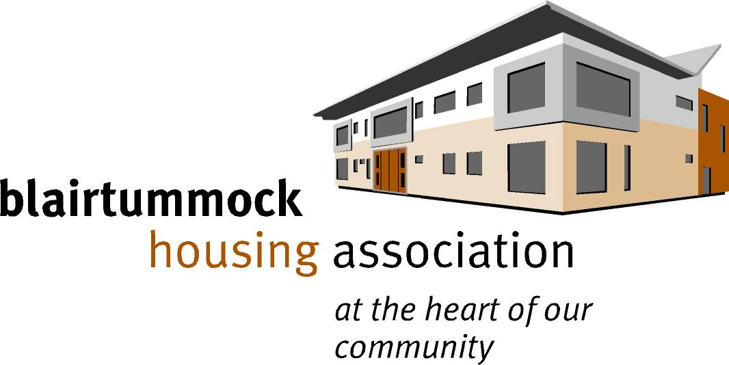

BLAIRTUMMock & rogerfield
COMMUNITY CHEST

Expression of interest

Community Chest is a new pot of money that we have pulled together to benefit the residents of Blairtummock and Rogerfield in Easterhouse, Glasgow. It is intended to be used to expand the opportunities of anyone living in the area, by removing the barriers they might face to leading happy, and fulfilling lives.

If you have an idea that could benefit you or a member of your household, in the way described above, please complete this form, and email it to communitychest@blairtummock.org.uk before Monday 17th August 2020.

About you

Full Name
Address
Post Code
Telephone Number
Email Address

Are you related to a member of, Blairtummock Housing Association Management Committee or Blairtummock and Rogerfield Opportunities Board or a member of staff of either organisation?

YES 🔲 NO 🔲

Are you completing this form for yourself or on behalf of someone else?

YOU 🔲 SOMEONE ELSE 🔲

What do you want us to pay for? Who will benefit from this, and how?

Costs

Where you are looking for an item of equipment, or something physical, the cost is a one off. However, where you are seeking support to pay for an activity, you will have to think about how long the activity will last. (examples are provided for illustration, please replace with your own costs.)

Item | One Off - Equipment/Item Costs | Ongoing - Activity Costs / fees and for how long
Mountain Bike (EXAMPLE) | £400
Mountain bike club fees (EXAMPLE) |  | £10 per month for 24 months
Total | £400 | £240

In total, how much funding will you need? | £

What age group does the person who will benefit from the funding come from?

Children (under 12) 🔲
Young People (12 - 18) 🔲
Adults (18+) 🔲
Older people (65+) 🔲

When are you hoping to start your funded activity? (Please note that we do not award retrospective grants):

How did you hear about our Community Chest?

A local Organisation made me aware of it 🔲
Internet search 🔲
Social media 🔲
Newsletter 🔲
Other, please specify:

In order to process your Expression of Interest and potentially make an award of funding, we need to record your details on our database*

Please tick the box to acknowledge that you give permission for us to hold your data for grant making purposes.

*The information will not be shared with any other party without your explicit permission. Our full privacy policy can be viewed by clicking here

Yes 🔲

No 🔲

